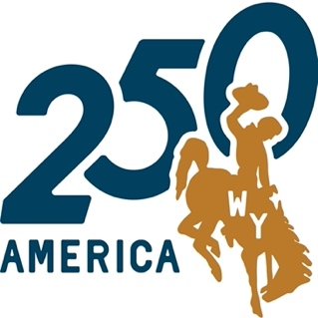
Free Greenhill Cemetery walking tour

HONORING WWI MILITARY & HOME FRONT SERVICE

Sponsors: Albany County Historical Society, Laramie Plains Museum (LPM), City of Laramie Department of Parks & Recreation. The tour begins at section (row) AA, south of the cemetery office and parallel to 15th St. Letters and numbers preceding names give the location of the gravesite on the map outside the Sexton’s office. See map, page 5.

INTRODUCTION to WWI (by Commander Kim Viner, U.S. Navy, Retired): Spurred by tensions arising from the creation of the German Empire, military and economic competition in Europe erupted in a continent-wide conflict we now know as World War I. Germany allied with Austria, Hungary, Bulgaria, and Turkey, invaded Belgium on August 4, 1914, the invasion resulted in an immediate response from France and Russia. Great Britain eventually joined on the side of France. The conflict resulted in millions of military and civilian deaths. The United States remained neutral until German naval attacks on U.S. shipping prompted a declaration of war against Germany on April 6, 1917. From then through November 1918, almost five million men and women served in WWI, including over 11,000 from Wyoming. Over 53,000 U.S. men were killed in action and another 63,000 died of other causes, mainly influenza. Albany County residents and University of Wyoming (UW) alumni accounted for more than 1,000 who served in the military, including 32 who perished while in service. They are commemorated on a 1924 monument originally located at the intersection of 2nd and Ivinson and later moved to the northeast corner of the courthouse block. UW professor Grace Raymond Hebard conceived the project, and it was funded by local philanthropist Edward Ivinson. This tour includes a select few of the 1,700+ veterans in Greenhill.

AA 3 SCHOTT, JOHN CHRIS (1896-1918) died at age 22 of influenza at the 8th Army Veterinary Hospital in France, along with two others from Albany County (Scott Ray Robertson and James Edward Pollock) who served at the same place. He was first buried in France; the Schott family had his body re-interred back home in 1921 when the government gave families that option. John’s brothers Paul (also a WWI veteran) and Delbert, his parents, and his father’s second wife, Cora Bartlett Schott, are also buried here.

A 45 BURNS, ROBERT HOMER (1900-1973) served in the UW Student Army Training Corps (SATC), along with dozens of others whose names are on the Albany County WWI monument. They were preparing to serve overseas, but were demobilized a month after the Armistice of November 1918 was signed and the SATC was abandoned. In 1931 Burns received a Ph.D. at Edinburgh University in Scotland, and he began a teaching and research career in the UW Wool Department. He was a former president of the Albany County Historical Society and founder of the annual Albany County Ranch Tours that began in 1950. His wife was Agnes Brown Miller. Burns was a co-author of the 1955 book, “Wyoming’s Pioneer Ranches”.

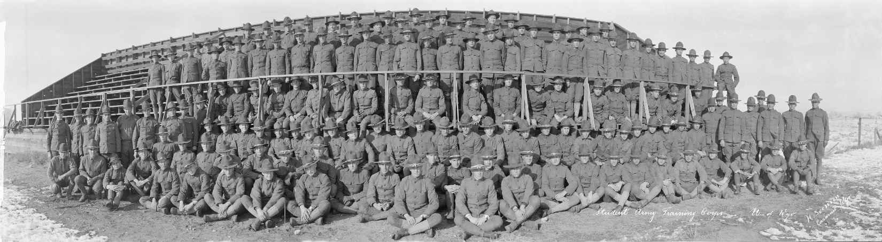

Robert Burns probably was one of the many men pictured here. He was one of the 170 volunteers in the Student Army Training Corps of 1918 at UW. Their commanding officer was Captain Beverly C. Daly, later UW Dean of Men.

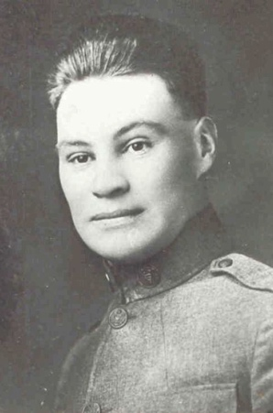
C 6 VASS, JOHN (1896-1918) grew up in the Harmony area where his Scotland-born parents James and Allison Vass ranched starting in the 1880s. Shortly before he shipped out with the Army, he married Gladys “Irma” Judd in Nebraska. She never met his parents. He was a “wagoner” in the Army Medical Corps; killed in France while driving what was probably a horse-drawn ambulance after taking wounded to the base hospital. A German shell burst directly over his head—he died instantly when struck by a piece of shrapnel. Five other men died in WWI who were from the Harmony area southwest of Laramie, they were: John Chris Scott, Joe Thomas, William Fremont Howe, James Pollock, and Herman Greaser. John’s photo is at the right.

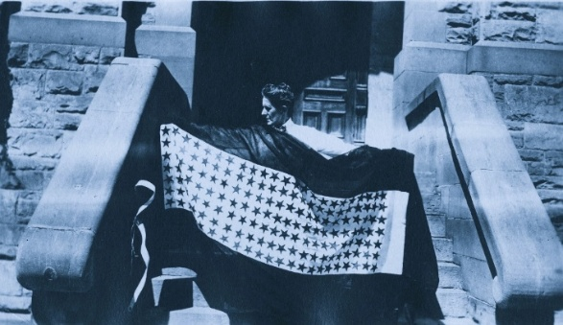
C 35 HEBARD, GRACE RAYMOND (1861-1936) was an Iowa native, a founding member of the Laramie Daughters of the American Revolution chapter, and home front war supporter of the Red Cross. Appointed to the UW Board of Trustees in 1891, she served as its secretary and then became a professor of political economy and the first UW librarian. She wrote several non-fiction books on Western trails and developed Americanization programs for immigrants. She persuaded banker Edward Ivinson to donate funds for the Albany County WWI memorial monument and researched the names to be listed. The photo shows Hebard on the steps of Old Main at UW with patriotic bunting for a patriotic pageant she wrote. The UW American Heritage Center (AHC) holds a large collection of her papers and photos.
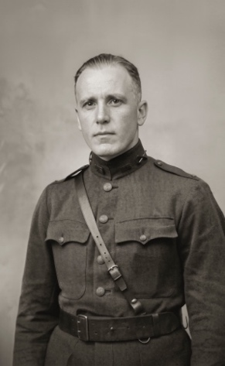
D 10 WILLIS, ANDREW (“RED”) WESLEY (1886-1974) served in both WWI and WWII. Following WWI, he was active in the Wyoming National Guard and became an extension economist at UW. In 1941, he served active duty at Fort Lewis, Washington and was transferred to the Army Air Corps. He retired as a colonel in the USAF in 1952. He married Amy Elizbeth Porter in 1922. His WWI uniform is part of the collection housed at the LPM, shown in his photo at the right.
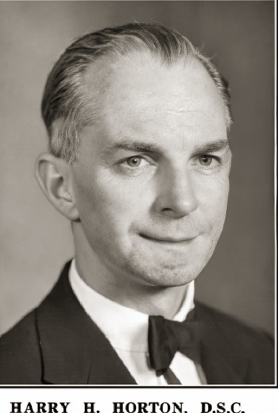
H 62 HORTON, HARRY H. (1889-1959) was born in New York and received a chiropractic degree in Chicago in 1915. The same year he opened an office in Laramie. He enlisted in the U.S. Army as a medic with the rank of Private 1st Class. His jaw was broken and much of the lower part of his face was torn away when his aid station was hit by shell fire. Despite being speechless and severely wounded, he summoned aid for his comrades and helped evacuate them. He was hospitalized until 1921 and underwent 22 major operations. In 1927 he married writer Marie Catherine Montabe Savaresy, who had been divorced from her first husband, Michael Charles Savaresy. There are two Savaresy children buried at this site with Horton, his wife, and her parents. Horton continued chiropractic practice until retirement and belonged to the Masons, Rotary, and Sons of the American Revolution. From 1926-1941 he served in the Wyoming State Senate as a Republican. He helped to found the Laramie VFW post 2221 in 1931. He received the Distinguished Service Cross in 1935. During WWII with the assistance of his wife, he was a recruiting officer for the Women’s Army Corps. Marie and Harry’s papers are in the archives of the UW American Heritage Center.
J 81 ARNOLD, THURMAN WESLEY (1891-1969) and brother CARL F. ARNOLD (1897-1941) both
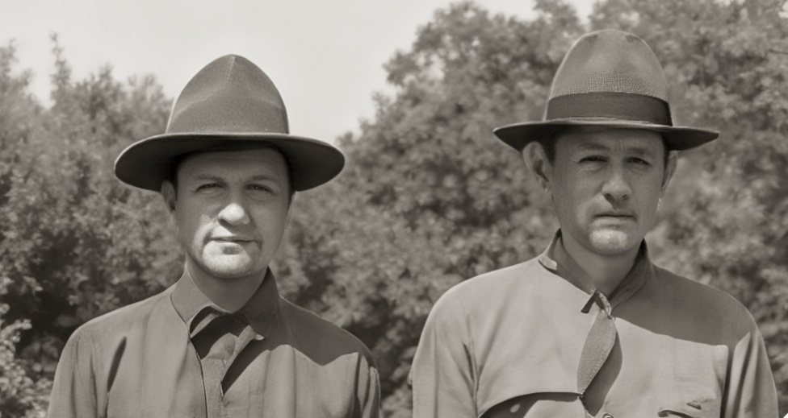
became attorneys and served as 1st Lieutenants in France in WWI. Thurman (on right in photo) graduated from Harvard Law School in 1914. He married Frances Longan just before WWI. He was mayor of Laramie for a time and in 1921 was the only Democrat elected to the Wyoming State Legislature. In 1927 he became Dean of Law at West Virginia State University, and he then joined the Yale law faculty in 1930. In 1933, President Roosevelt appointed him as head of the antitrust division of the U.S. Justice Department. Carl became Dean of the UW Law School, the first UW law graduate to do so; later he and his wife Olga moved to Washington, DC. The photo shows the brothers on a home visit to Laramie after basic training.

L 94 DOYLE, WALTER EDWARD (1889-1963) was appointed to the US Naval Academy in 1909. After graduating, Lt. Commander Doyle became skipper of the USS Seawolf submarine operating along the Atlantic coast in WWI. He continued to command submarines in the Pacific in WWII. He retired as a Navy Captain and returned to Laramie in 1943 with wife Gertrude Anna (who predeceased him in 1958).
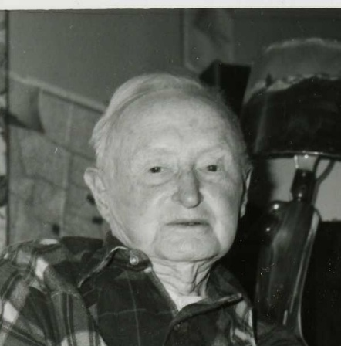
Q 65 GRIER, HENRY LEE (1896-1983) was a UPRR telegrapher, he and his wife Jessie moved to Laramie from the Pine Bluffs station post-war. He served in the Army Signal Corps in France, for which he learned International Telegraph Code, which differed in the spacing between letters and words. He knew Railroad or U.S. Morse Code, obsolete now. He needed surgery close to the WWI armistice date; he was released from the hospital with a random uniform—it was required to board a ship home. Returning “doughboys” (the term originated during Pershing’s expedition against Pancho Villa in Mexico from dust or “adobe” covered troops) were given $60 to buy civilian clothes by the government. He resumed his railroad career and trained several local women in telegraphy—telegrams were phased out in the 1980s.

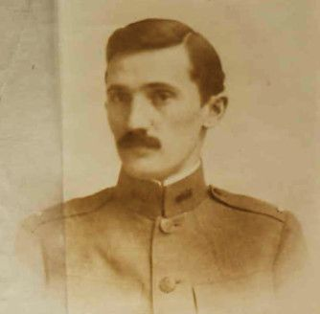
S 66 KNIGHT, SAMUEL HOWELL (1892-1975) was born in the Keystone, WY, mining district where his geologist father Wilbur was superintendent. Sam grew up in Laramie when his father was named UW Professor of Geology in 1893. Wilbur died unexpectedly ten years later; Sam followed in his footsteps and graduated in geology from UW. He received a Ph.D. in geology from Columbia University and married New York City native Edwina Hall in 1916. In 1917, Sam was asked by his major professor at Columbia to join the U.S. Army Intelligence Service to do “special inquiry” work at the front in France and other countries, advising on natural battle fronts and natural barriers. In this service, he had the rank of 1st Lieutenant. Sam’s brother Everett also served in France and another brother, Oliver, served stateside in WWI. After the war, Sam returned to UW and began five decades of award-winning teaching and scholarship in geology. The S.H. Knight Geology Building at UW is named for him. In 1999 Samuel was posthumously named “Wyoming’s Citizen of the Century” by the Wyoming Historical Society. His widowed mother Emma was a home front Laramie Red Cross volunteer in WWI and became the first Dean of Women at UW. Knight Hall at UW is named for her.

S 42 CORTHELL, ROBERT C. “ROBIN” (1891-1978) was one of four Corthell brothers who served in WWI; Irving, Morris, and Huron Corthell also served, as did his brother-in-law, John Hill. Robin enlisted in the U.S. Marines and became a corporal in the Sixth Regiment at the Battle of Belleau Wood, about 60 miles east of Paris, on July 19, 1918, where he earned the French Croix de Guerre for heroism. Also buried here are Gladys Corthell Hitchcock’s relatives who served in WWI: Edwin Niles Hitchcock (1893-1955), who served in France; Samuel Hitchcock (1894-1964), who served stateside; and William A. Miller (1895-1959), who received a Purple Heart for wounds suffered in WWI. Miller married Carrie Hitchcock in Laramie in 1921. Robin was survived by his wife Frances McPhee.
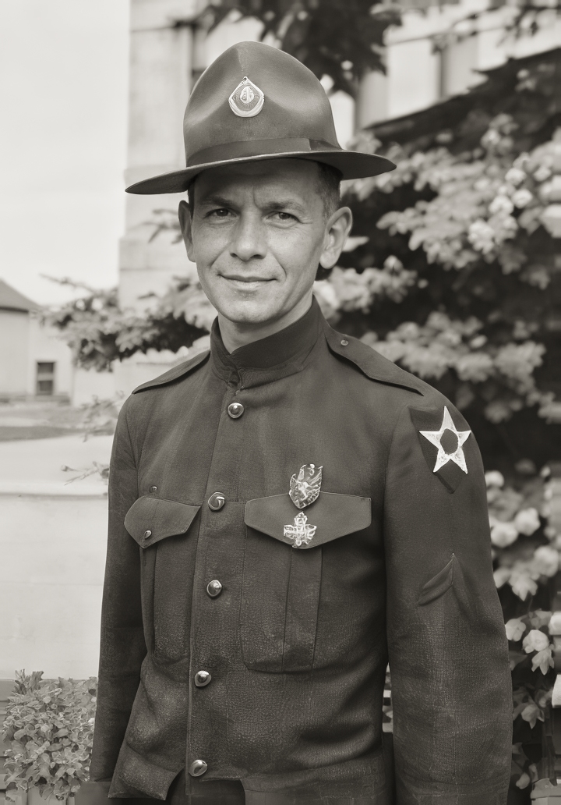

ESS 77 67ER WHITE, ROSE ELIZABETH (1891-1973) was born in Old Rock Creek, Albany County. Rose served in the Army Nurse Corps at the 29th Base Hospital in England during WWI. In 1921 she married Royal Young; they published the Rock River Review newspaper. They were divorced by 1929, and she took back her maiden name. Her photo is on the right below. Her brother John is buried in the row in front; he also served in WWI.

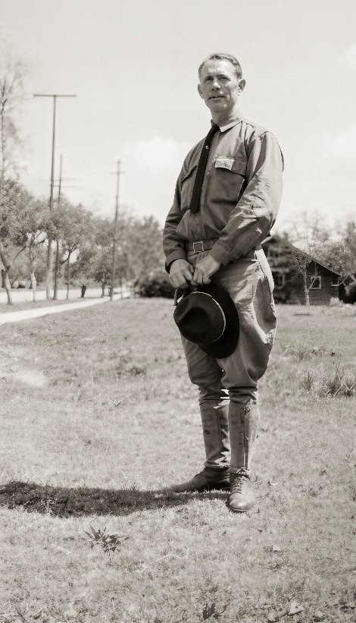
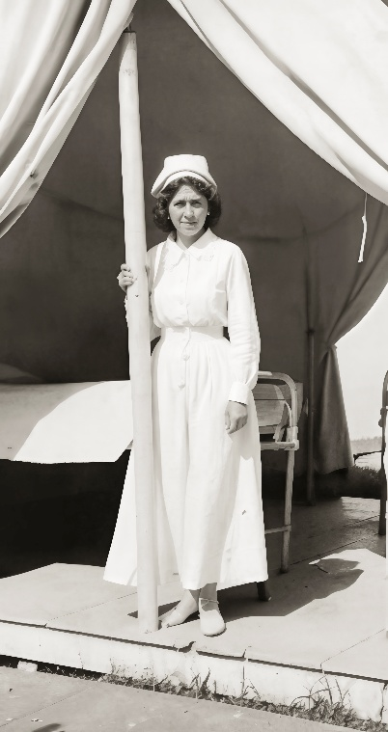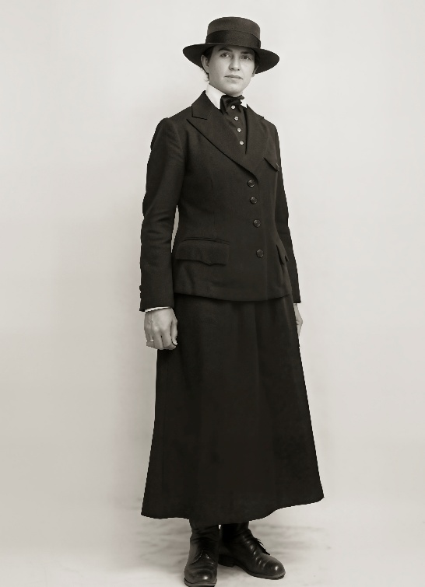
77 35 HULL, PEARL THERESA (1884-1965) was a Michigan native (photo far left in a hospital tent somewhere in France). She made the Navy her career and served from 1917-1945, retiring as a Commander at the U.S. Naval Hospital in Bremerton WA. She had served in many stateside and overseas naval hospitals through WWI and WWII. She retired to Laramie, joining several relatives who were residents here.

76 2 BELLAMY, FULTON DODD (1895-1978) a Laramie native, enlisted in the U.S. Army in August 1917 and was discharged December 12, 1918, as a 1st Lieutenant. He married Willamena Edith Picheau in 1945. In the 1950 census they lived in Kansas City, Missouri, where he was an airport engineer. His father Charles Bellamy was the first licensed engineer in Wyoming. Fulton’s two sons were graduates of UW and became engineers also, a family tradition passed down to the next generations. His mother, Mary Bellamy, was a Home Front activist, promoting Liberty Loans, war bond drives, and the Red Cross.

Photographs: Page 1: from the UW American Heritage Center (AHC).
Page 2: Vass from family member Helen Fagerburg; Hebard and Willis from LPM;
Horton from findagrave.com. Page 3: Arnold brothers from AHC; Grier from LPM; Sam Knight from findagrave.com. Page 4: all photos are from family members’ collections.

